Module

* Customer Relationship Management

Description

* Contains all customer information. Shows communication history and all purchases between customer and the business. A necessity for employees when dealing with clients efficiently.

Functions

1. customerRecord

- A function that presents all data on customer and transactions with the company. And also for adding new customer data or updating customer information in the database.

2. deliveryTracker

- A function that enables the tracking of all products purchased or ordered by the customer and notifies when customers receive them or if anything else happens to them.

Hierarchy

Customer Relationship Management

deliveryTracker

customerRecord

Start

///call module and function///

Module customerRelationshipManagement

Function customerRecord()

End module

Start

///get user to input data///

PROMPT new customerRecord(){

///used to process the data from input///

GET customerRecord

///used to keep the loop running until the user is done///

SET looping TO TRUE

///used to keep loop asking for new records///

WHILE looping = TRUE DO

///used to allow user to keep entering customer records///

RECEIVE new record FROM KEYBOARD

///used to end or quit loop///

IF new record = ‘SHIFT’

THEN stop

///loop won’t run due to false condition///

SET looping TO FALSE

///show the output///

DISPLAY updated customerRecord

End

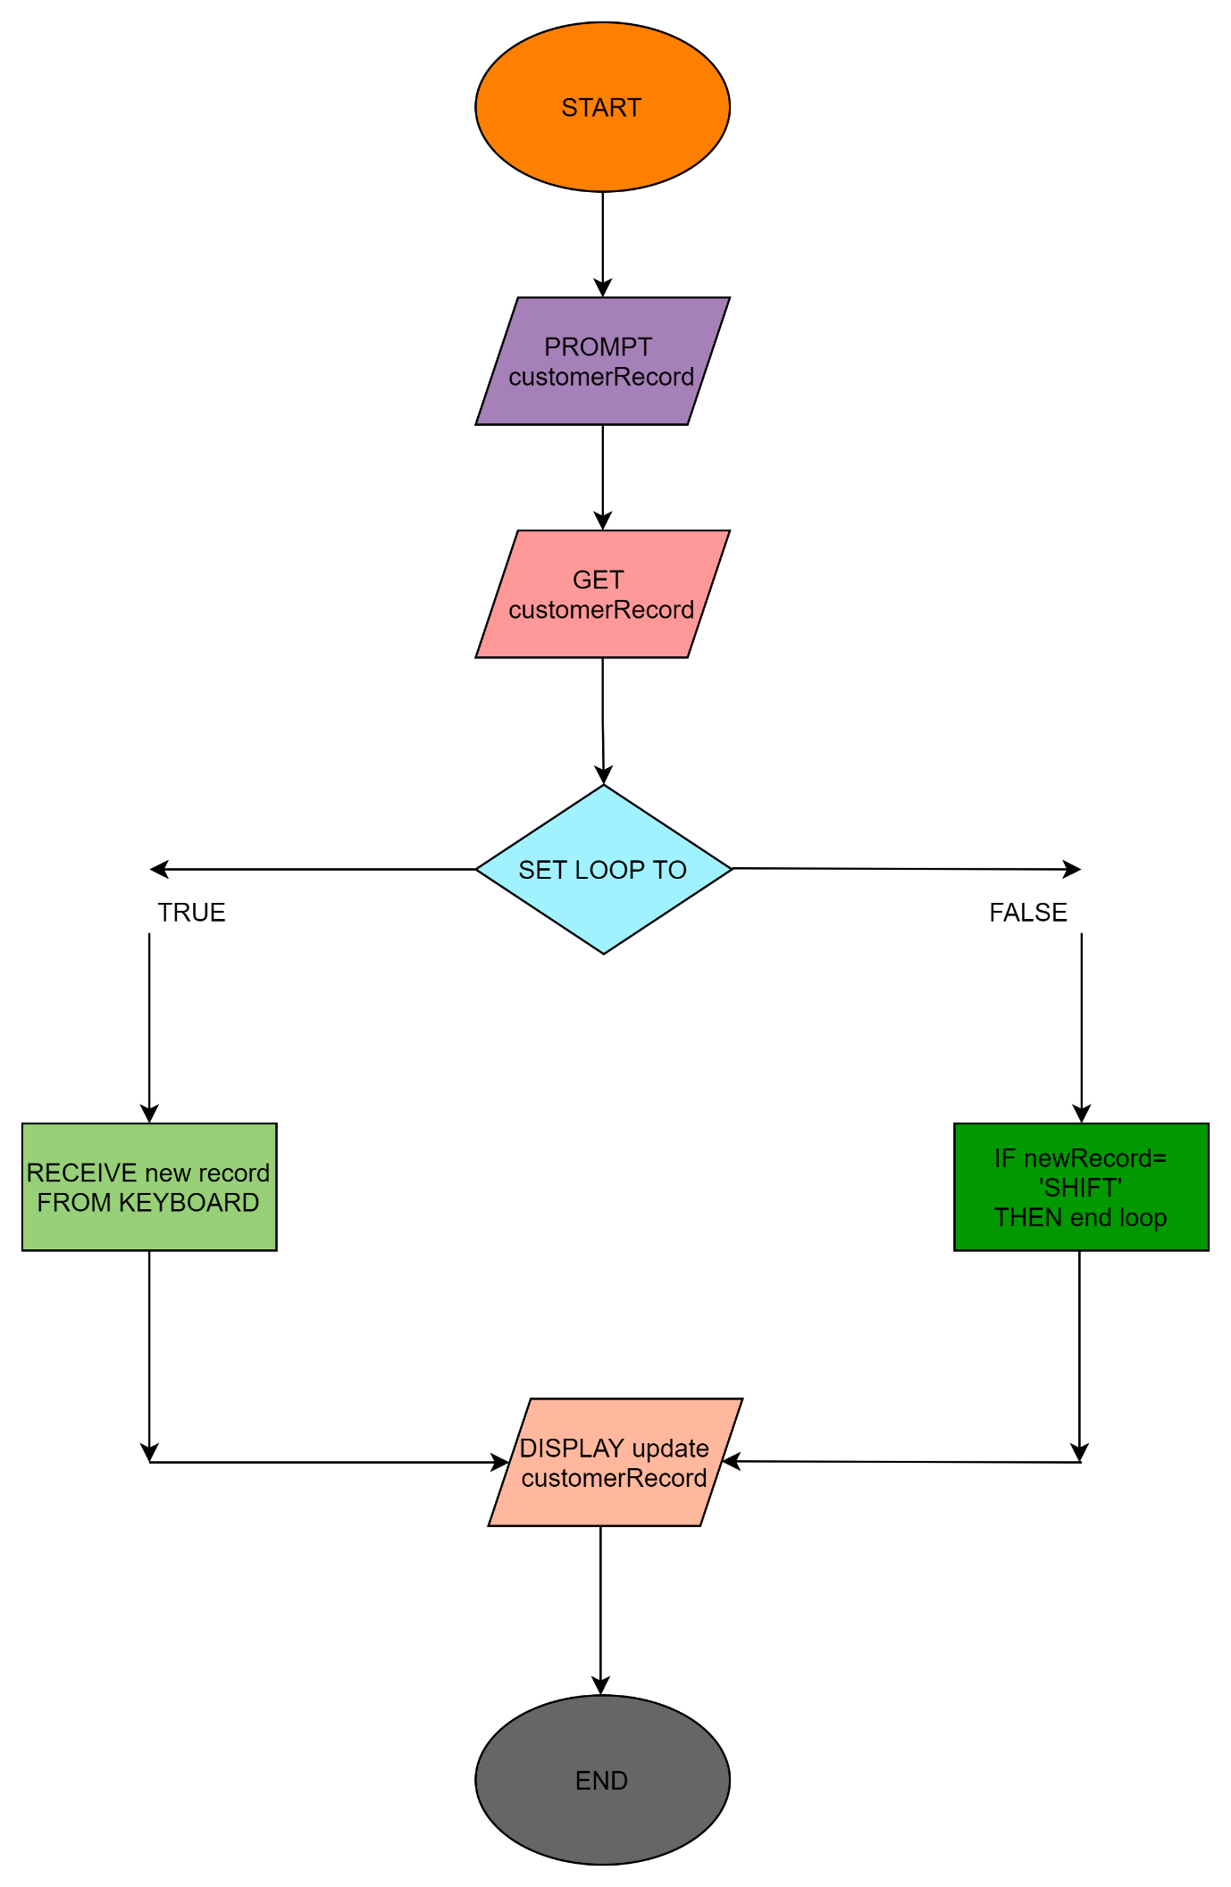

Start

///call module and function///

Module customerRelationshipManagement

Function deliveryTracker()

END

Start

///get input from user///

PROMPT deliveryTracker

GET deliveryTracker

/// used to allow user to keep entering delivery status///

RECEIVE deliveryStatus FROM KEYBOARD

IF status= delivered

THEN Print “Received”

IF status= onTheWay

THEN Print “Enroute”

IF status= deliveryCancelled

THEN Print “Return Stock”

IF status= damaged

THEN Print “Return to inventory”

///shows the output///

DISPLAY deliveryTracker

EndIF

END

